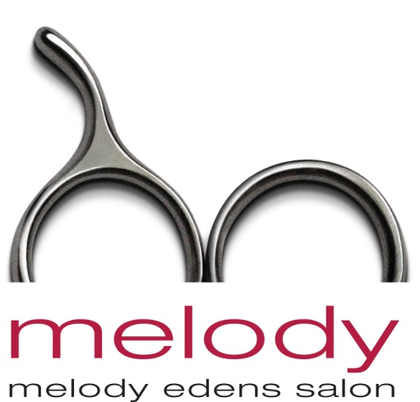

Contact: Melody Edens, Owner
Melody Edens Salon
148 E. Huisache Avenue
San Antonio, TX 78212
210-734-3556
OR
Sharon Esche-Irving
Esche & Alexander PR, Inc.
760-414-3370; sharon@beauty-pr.com

FOR IMMEDIATE RELEASE (w/photos)
San Antonio Salon Hosts Event To Support Cause
(additional photos available upon request)

"LOVE IS IN THE HAIR" FUNDRAISER AT MELODY EDENS SALON:
SAN ANTONIO SALON SUPPORTS AMERICAN HEART ASSOCIATION.

San Antonio's Melody Edens Salon celebrated beauty for a cause on Feb. 7, 2017 by hosting their "Love Is In The Hair" fundraiser, in support of the American Heart Association.

Guests and media gathered at the trend-setting salon for a fun reception plus salon team seasonal fashion updates in cut, color and cosmetics (plus image consultations, makeup touch-ups, and complimentary beauty gifts). The evening's live-model presentation featured beautiful red dresses (from Macy's) in support of National Wear Red Day, and showing head-to-toe finished fashion looks, inspired by the runways of New York Fashion Week to L.A.'s celebrity red carpet.

Presenting on behalf of the salon were owner Melody Edens, Ariana Ovalle and Grace Elmer. Featured products included the salon's own signature line of haircare/styling and make-up products. The Melody Edens Salon is "San Antonio's Only American Board of Certified Haircolorists' Salon" (ABCH), whose total hair design team is uniquely and nationally recognized for their fashion-forward creativity, techniques and skills in hair cutting/styling and coloring.

Click on photo to download to your browser and save
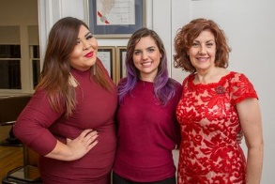
The Melody Edens Salon design team who hosted  “Love Is In The Hair” were, left to right: Ariana Ovalle, Grace Elmer and Melody Edens. | Models with Swain Edens, husband of Melody and co-owner of Melody Edens Salon at “Love Is In The Hair’ trend event supporting the American Heart Association.

###

