Contact: Sharon Esche-Irving, Esche & Alexander PR
760-414-3370; sharon@beauty-pr.com

MELODY EDENS SALON IN SAN ANTONIO HOSTS
“WOMEN & WINE ON WEDNESDAYS” NETWORK MIXER
San Antonio – The Melody Edens Salon recently hosted over 50 members of San Antonio’s “Women & Wine on Wednesdays”, a business and social network for women that holds monthly meetings in various locations throughout the city to build new relationships, share resources and discover new opportunities.
Salon owner Melody Edens offered her location as a meeting place because she believes that ‘the salon should be a pampering place not only for beauty services but for bringing beauty to life within the community at large’. According to Edens, owners should also think of their salon as a comfortable, familiar environment for education and inspiration that welcomes clients and guests after working hours.
Salon team stylist Ariana Ovalle, also a member of the organization, summed up the June 21st evening as ‘a fun and productive experience for everyone who attended and participated’. Said Ovalle: “It felt great to host my peers in my own professional world of the salon. Although they had their own business agenda for the evening, they also learned more about the exciting business of beauty.”
Every monthly meeting of “Women & Wine on Wednesdays” features a community group spotlight to benefit a local non-profit group. They selected the National Ovarian Cancer Coalition (NOCC)/San Antonio Chapter, also supported by Melody Edens Salon for several years. NOCC supports quality of life initiatives for survivors and caregivers.
Click on photo to download full-resolution image into your browser, then save.
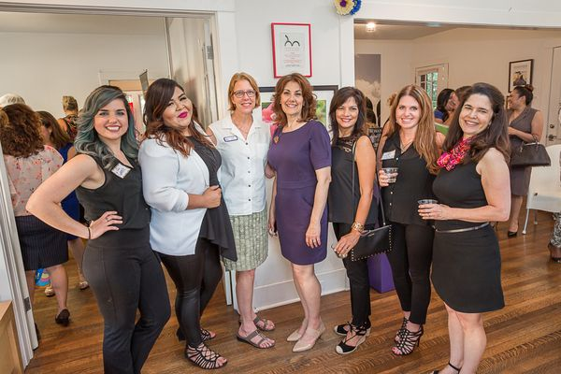
Left to Right: Grace Elmer, Ariana Ovalle, Diane Carl (Women & Wine San Antonio board member), Melody Edens, Margie Hildreth(salon client & award winning watercolor artist), Chastity Matthews (Women & Wine San Antonio founder), Linda Brewster (Women & Wine San Antonio founder)

